To boost those reading skills, learn to keep a beat, study says

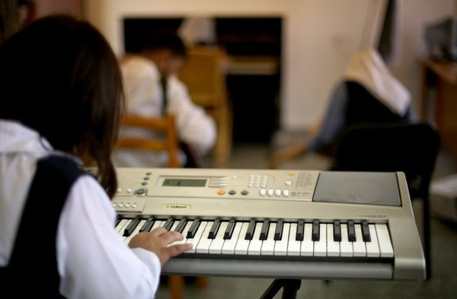
Research shows that keeping a beat and reading skills may rely on a common part of the brain, according to a study in the Journal of Neuroscience. (Mohammed Abed / AFP / Getty Images)

By Amina Khan
September 18, 2013, 6:42 a.m.
Learning to move with the beat could boost reading skills because both abilities are partly powered by the same ability in the brain, according to a study of more than 100 finger-tapping Chicago high-schoolers.
The findings published in the Journal of Neuroscience indicate that musical training could strengthen areas of the brain involved in understanding speech.
Previous research has found that beat-keeping skills and reading ability seemed to be in sync, according to the study's authors. But for this paper, the two scientists fromNorthwestern University examined a common part of the brain that could link both these abilities.
The researchers first took 124 Chicago-area high schoolers aged 14 to 17 and asked them to follow a beat tapped out by a metronome at either 1.5 Hertz and 2 Hertz. Some were better at keeping time than others. (There was also a latent language element present: Those rates “overlap with the rate of stressed syllable production in conversational speech,” the authors wrote.)
In a second experiment, the scientists had the students listen to the repeated syllable “da” and measured their neural response in a part of the brainstem that contains the inferior colliculus, which acts as a central hub for auditory processes.
They found that those students whose brains' auditory hubs responded consistently over time to the repeated “da” syllable were also the ones who could keep up with the metronome's beat.
In understanding language, timing is everything — slight differences in timing can help listeners distinguish sounds like a "p" or a "b," for example. So hearing and recognizing those tiny distinctions is just as important for language as recognizing and following the tempo of a rhythmic beat is for music.
“The acquisition of reading and beat synchronization ability may relate because both rely on consistent timing within the auditory system,” they concluded.
So perhaps exercising this beat-keeping part of the brain by practicing music could also enhance language abilities, they said. And it could improve reading skills too, since reading relies on a person's ability to understand the speech sounds encoded in the letters.
“It is possible that training in rhythmic abilities including beat synchronization practice could lead to a more stable neural representation of sound, in addition to improving linguistic skills, such as phonological awareness and reading,” the study's authors wrote.

