It’s Party Time!

August 22nd-November 15

For our first project of the year we will be exploring the world of politics and government! Students will be learning about the role of government, voting, elections, and political parties along with what it means to balance individual rights with group rights.

Students will form groups and go through a series of challenges and activities that culminate in forming their own political party. They will then create a campaign designed to convince visitors at Exhibition to vote for them. This campaign may include: speeches, commercials, ads, debates, symbols, and slogans, which will be created as a group or as individual deliverables by members of the group.

Driving Questions

How to we balance individual rights with group rights? How do people make decisions as a group? Why does government exist? How do we create political parties that represent what we feel is important?



**Home Extensions**

* Study the history of voting in the U.S
* **Write a biography of an important political figure (president, activist)**
* **Research political pets and write a piece from their point of view**
* **Create mini national monuments**
* **Study polls and surveys, create your own**
* **Create a family constitution**

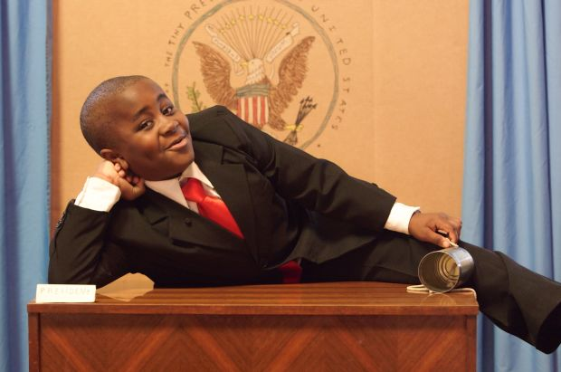

**Skills/Standards**

**Social Studies:**

* Students describe the rights and individual responsibilities of citizenship.
* Students explain governmental institutions and practices in the United States and other countries.
* Students know and understand the symbols, icons, and traditions of the United States that provide continuity and a sense of community across time.
* Students understand the importance of individual action and character and explain how heroes from long ago and the recent past have made a difference in others’ lives

**Writing**

* Write opinion pieces in which they introduce the topic or book they are writing about, state an opinion, supply reasons that support the opinion, use linking words (e.g.,*because*,*and*,*also*) to connect opinion and reasons, and provide a concluding statement or section.

**Math**

* Draw a picture graph and a bar graph (with single-unit scale) to represent a data set with up to four categories. Solve simple put-together, take-apart, and compare problems1using information presented in a bar graph.