Just Right Reading
- Choose a book that looks interesting 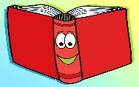
- Read 1 page
- Hold up a finger for each word you do not know
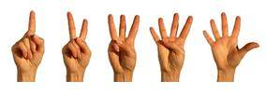
- 5 or more fingers= too hard
0 fingers= too easy

