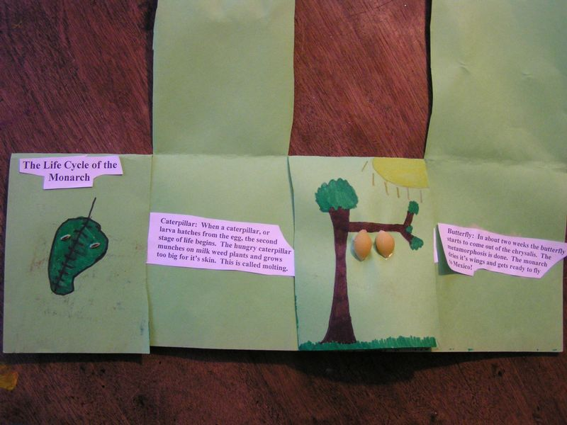
Inside the Foldable Flaps|Tammy Andrew
The butterfly's metamorphosis is a convenient cycle to use for introducing young children to the concept of life cycles in nature. The following activity can be used in K-2 classrooms, which are the typical school grades when children learn about the four stages of a butterfly's life. It can be incorporated into existing lessons after students are introduced to the life cycle or as a task in a WebQuest.

How to Create a Foldable Display
Each student will start with a large piece of paper, 11” x 17” is ideal but other sizes will also work. Colored paper should be light enough that children can color pictures on it. Students will also need access to scissors.
The paper should be folded in half by placing the long edges together and making a crease. Next, place the paper so that it opens towards the child and help him/her cut the top part into four sections. The cuts should stop at the crease, resulting in four liftable flaps.

Making Pictures of the Butterfly's Life
Once the paper is folded and cut, students create a picture on each flap to represent each stage of the butterfly's life cycle. They will need crayons, markers or colored pencils, glue, and the following pasta shapes: orzo, spiral, shell, and bow ties.
On the first flap students should draw a leaf with caterpillar eggs, or larvae. Orzo or other small, egg shaped pasta are glued to the leaf to represent the eggs. Some space should also be left near the top of the flap for a title.
The second and third flaps represent the next two stages. The picture for flap two should show caterpillars on leaves or in the grass, using spiral shaped pasta for the caterpillars. Flap three would be for the cocoons, or chrysalis, using medium size shell pasta for the now enclosed caterpillars.
The final flap is for the butterfly. This picture needs to have bow ties glued to it to represent the butterfly after emerging from the cocoon. Children should draw an appropriate picture to accompany the butterfly.

Writing Descriptions of a Butterfly's Life
Students will place a description of each stage under the flap with the picture. This can be modified for each child depending on language skills, but should contain a brief description using the appropriate word for their level for each stage. For example, a kindergartner might label stage 3 as, “Cocoon. Caterpillar changes into a butterfly,” whereas an advanced second grader might label the same stage as, “Chrysalis: The third stage of life begins when . . .” and describe the process in two or three sentences.
Children can write the descriptions by hand or use a computer to practice keyboarding skills. In either case, the written work can be on a separate piece of paper, cut out, and glued onto the foldable display. Students should check their own work or peer edit each description before gluing.
Using a foldable display and pasta to create a project to show the butterfly's life cycle is a fun way for young students to put the concept into pictures and words. It allows for students to be creative with the drawings while showing what they learned. The writing part can also be modified for the language or grade level of each child in the classroom.

